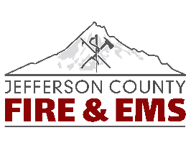
EMS NEWS
July/Vol 1/Edition 4
IN THIS ISSUE
- Local Connections
- Training
- EMS Equipment & Supplies
- SCMC-JCF&EMS Connections
- Regional & State Activities
- Community

Here’s the scoop on happenings in EMS at Jefferson County Fire & EMS
By Dep Chief Michael DK Lepin
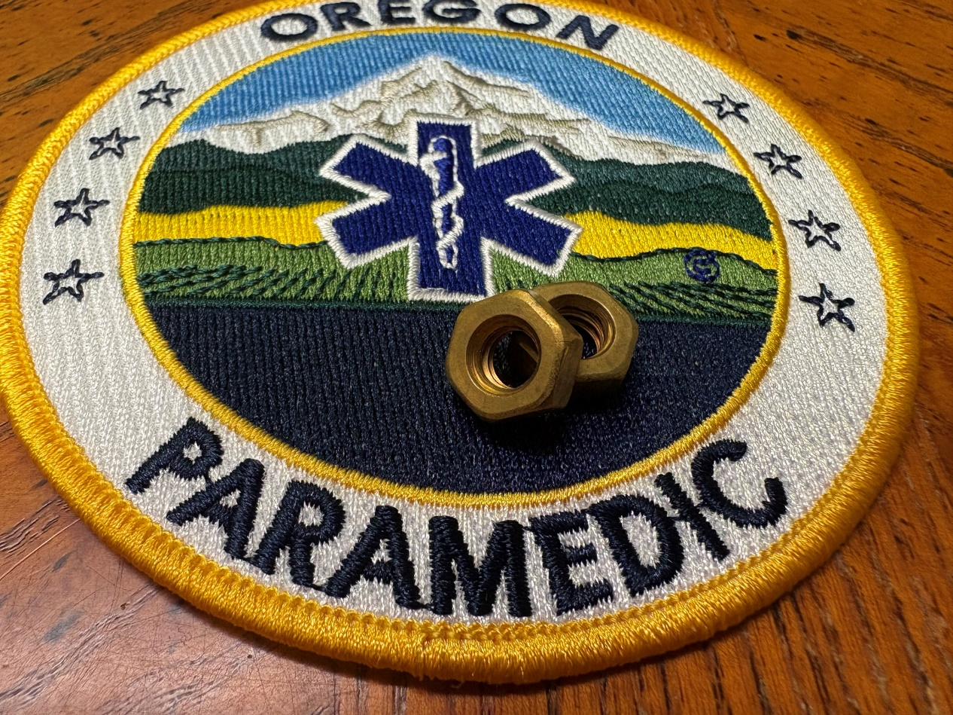
When things get complexed and difficult in EMS, always remember the basics, “nuts & bolts”. This will keep you out of trouble.
I was taught this early in my career. To remind us all in our paramedic class, the instructor gave each of us a nut to put on our keyring, a visual reminder to remember the basics. I have shared this little nugget on to my EMT & AEMT students.

Cover Photo Competition: Hey everyone, I am looking for cool EMS photos to use for the cover photo of this newsletter. If you have one that you think is great, send it to me. The only requirement is it must be EMS related (not fire). At the end of the year, we’ll take a vote, and the most favorable photo used throughout the year will win a prize.
Local Connections
No local connections made for June but watch for July!
Training
Fall Rodeo: Will be on Monday, September 15th. This rodeo’s class line-up is: Trauma Update, Human Trafficking, Hospice, Elder Abuse, & Child Abuse.
More Vent Training: I have been in communication with Denny, an RT from SCMC, who will be coming in for some training. He will only be able to come in for one day so I will record the training.
De-Escalation/Defensive Tactics/Restraints: With the recent assaults on our crews, we are going to provide training to give you some extra tools to protect yourselves. I’m working with people at the Sheriff’s Office who have skills in Crisis Negotiation and Defensive Tactics. Stay tuned!
Equipment & Supplies
Binder Holders: After some discussion the EMS Committee felt organizers that hang on the back of a seat would be ideal for the resource binders in the ambulances. These have been purchased and have been installed on the back of the airway seat in each ambulance.
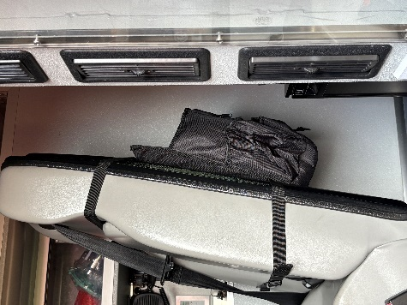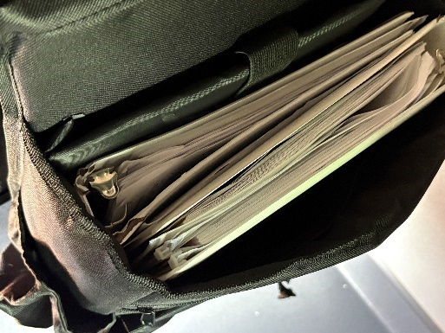

- Video Laryngoscopes: We are closer to getting our new C-MACS, just waiting on the process. Stay tuned.
- CPR Manikins/AED Trainers: We were successful in obtaining grant funding from the Roundhouse Foundation. With these funds we purchased new CPR manikins and ZOLL AED trainers. Manikins are here. The AED trainers will arrive in a couple weeks.
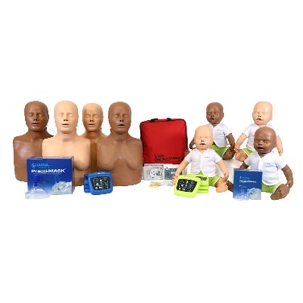

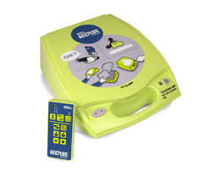

SCMC-JCF&EMS Connections
Compliment: Dr. Parker, now the trauma medical director for the three northern SCMC campuses, passed along that the site inspectors for Madras went out of their way to compliment Jefferson County Fire & EMS for our great patient care. It is not entirely clear what they were tracking but Dr. Parker stated it was a compliment specific to our agency.
Strong work all! Keep up the great work!
Transfer Center: Daniel Davis is no longer the Director for the Transfer Center. He has moved on to other adventures. I met with the new director, Rebekah Bruce in the early morning of the 18th. Rebekah and I will continue our monthly meeting to discuss any issues or successes.
Inter-Facility Transfers from the Family Birthing Center: Some questions came up from SCMC, primarily the FBC, about what are capabilities are when transporting pregnant people who may need Mag. What reversal meds do we carry and what meds do we carry to manage blood pressure. In the end, these are the guidelines for transporting from the FBC:
- FBC patients who are at higher risk, which Mag gtt qualifies, transport via air or critical care ground should be the first consideration.
- If the patient is requiring IV BP control measures via IV via push (not a gtt) critical care is the transport method.
- If critical care transport is not a possibility the use of Calcium Chloride is a viable option for managing Mag toxicity with adjustment of dose communicated prior to departure, this should not be the first line response for these patients.
- Meds used by EMS should come from EMS. Dr. Welle is correct is saying the Pharmacy does not like sending medications via transport and they have good reasons and rules regarding this.
Regional & State Activities
OSAA’s Balanced Billing Bill, House Bill 3243: this has passed through the House and the Senate and is waiting for the Governor’s signature! Woooo hoooo
EMS Modernization: House Bill 3572 has crashed and burned at the budget committee. This is unfortunate as it has received a lot of support from both sides of the isle but it was just too much of an ask financially. However, House Bill 3380 was absorbed into a large tax credit omnibus that has passed the House and Senate. If the Governor signs this, then what this means is the tax credit for volunteer EMTs will continue until 2030 and it is increased from $250 to $1000.
Community
I wanted to point out that we received great community service from Butcher Boys in Prineville. When I asked for pig tracheas with lungs attached, that was no small ask. It requires them to go out of their way to carefully remove them while protecting their integrity. This cost them time and effort when they would not normally do this when harvesting a pig. Then to top it off, they refused to charge us for this service.
For their kindness, the picture below was added to a framed ‘Thank You’,” which many of you signed. When I dropped it off to them it caught them by surprise, and they were appreciative of the gesture. Their reply was, “call us anytime...” I answered that next year we sure will.

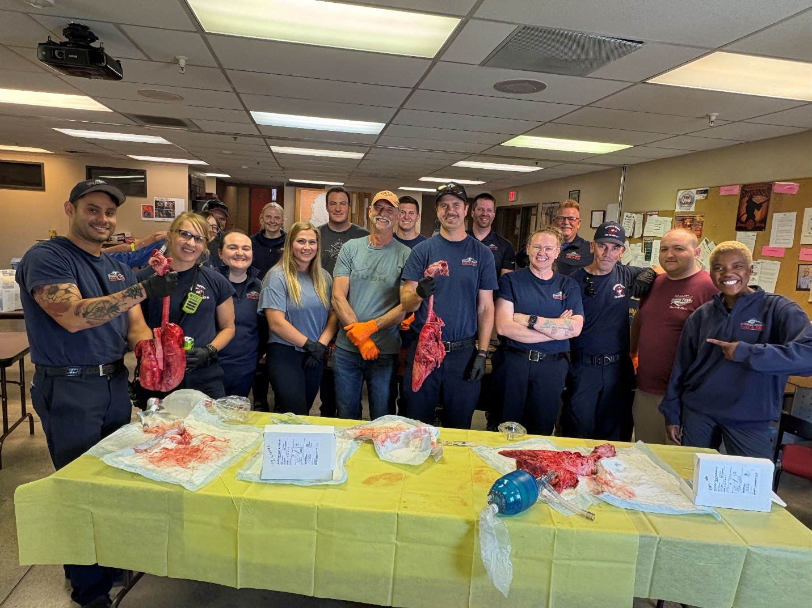

Surgical Airway Training using Pig Trachs with Lungs

