Attachment: Resolution 2025-2026 #11

The attached supplemental budget has been prepared in compliance with Local Budget Law after a thorough review of the Jefferson County Fire & EMS District’s revenues and expenditure expectations for FY 2025-2026.

Motion: I move to approve Resolution 2025-2026 #11, a supplemental budget for FY 2025-26.

RESOLUTION NO#2025-2026 #11

A RESOLUTION AUTHORIZING AN INCREASE IN APPROPRIATION TO RECOGNIZE
UNANTICIPATED REVENUES, AND EXPENSES, AND TRANSFER APPROPRIATIONS
WITHIN FUNDS FOR FISCAL YEAR 2025-2026.

WHEREAS, in accordance with ORS 294.456 and 294.463, the governing body of the Jefferson County Fire & EMS District, Madras, OR may increase appropriations to recognize unanticipated revenues, expenses, and to transfer appropriations within funds for Fiscal Year 2025-2026 that were authorized by the Board of Directors pursuant to Resolution 2025-2026 #11 ; and

WHEREAS, unanticipated revenues and expenditures were unknown at the time the budget was prepared and the Board of Directors deems it advisable to adjust the Fiscal Year 2025-2026 appropriations to be in compliance with Oregon Budget Law; and

WHEREAS, in recognition of; an adjustment that includes a transfer of appropriation from contingency of greater than 15%; and an increase of appropriation of greater than 10%; a notice of a supplemental budget hearing was posted in the Madras Pioneer on June 17, 2026 in accordance with ORS 294.471 (3) (b).

NOW, THEREFORE, BE IT HEREBY RESOLVED by the Jefferson County Fire & EMS District Board of Directors as follows:

SECTION 1: The Board Chair and Board of Directors determine that it is necessary to transfer and increase appropriations for the 2025-2026 District Budget.

SECTION 2: The Fire Chief is hereby authorized and directed to execute the following changes to appropriated budget amounts on behalf of the District:
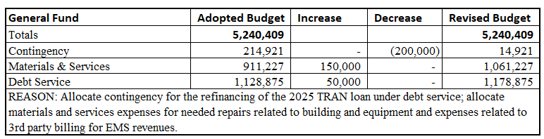

SECTION 3: This resolution shall become effective on June 24, 2026.
APPROVED by the Jefferson County Fire & EMS District Board of Directors and signed by the Board Chair this 24th day of June, 2026.

Ayes: _____
Nays: _____
Abstentions: _____
Absences: _____
Vacancies: _____

____________________________________
Name,

ATTEST:

Name,

